**5. WAVES IN 2D**

* 1. **AIM**

1. Observe waves in water in a ripple tank.
2. Observe various phenomenon like reflection,transmission of waves.
3. To determine wave velocity of surface waves
   1. **PRINCIPLE**

Two dimensional water (surface) waves travel along the boundary between air and water. The restoring forces for wave motion are surface tension and gravity. Most characteristics of the waves depends on the wavelength and water depth; as these forces acts differently at different water depths -

1. If the depth is shallower than ½ of the original wavelength, they are called shallow water waves. The speed of shallow water wave is described by :

$$v=\sqrt{gd}$$

where, d= depth of the water (in meters)

1. For deep water waves, the equation for speed will be :

$$v=\frac{λ}{T}=λf$$

Where, $λ$ = wavelength

T = time period

*f* = frequency of the wave

Speed of deep water wave will be approx. given by :

$$v=\sqrt{\frac{gλ}{2π}}$$

**[NOTE**: speed is directly proportional to the square root of wavelength]

* 1. **EQUIPMENT REQUIRED :**

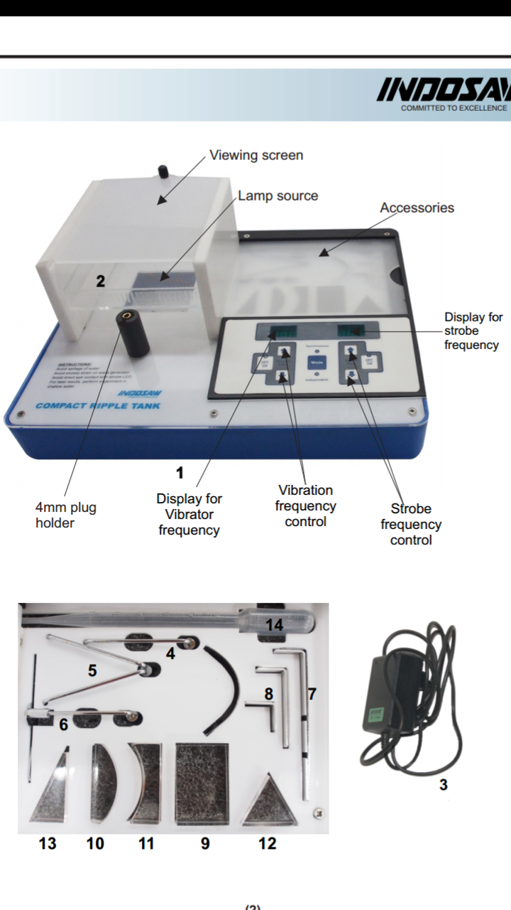 

Accessory box

Figure 1: Experiment Set up for Ripple Tank

**5.4 PROCEDURE:**

1. Place the plane wave dipper into the stem.

2. Pour water into the tank in such a way so that only the bottom tip of the dipper just

touches the water surface.

1. Switch on the unit. By default, it is set to '*Synchronous Mode*.'
2. Switch on the 'Vibration Freq.' and 'Strobe Freq.' by pressing the respective OFF/ON keys.

5. Adjust 'Vibration Freq.', 'Strobe Freq.' and ‘Strobe Intensity' to have the desired wave

patterns. Also use the dropper to change the water level to obtain the clear pattern (if

needed).

1. Measure and record the distance of five wavelengths. Calculate average wavelength.
2. Repeat the measurements at 4-5 other frequencies.
3. Fix a frequency and find the wavelength by changing the depth of the water.

For constant water depth –

Depth of water = cm = m

|  |  |  |  |
| --- | --- | --- | --- |
| Frequency (*f*) | Wavelength 5 *λ* |  |  |
| Hz | m |  | ms-1 |
|  |  |  |  |
|  |  |  |  |

For constant frequency –

Frequency = Hz

|  |  |  |  |
| --- | --- | --- | --- |
| Depth of water (d)  [cm] | Five *λ*  [m] | $$λ_{mean}$$ | $$v=λf$$ [${ms}^{-1}$] |
|  |  |  |  |
|  |  |  |  |
|  |  |  |  |

b

**5.5 STUDY QUESTIONS:**

1. What are surface waves? State their properties with example.
2. Does water move out with the ripple as the wave passes? Explain mathematically.
3. Which kind of velocity of wave is observed in this experiment – particle velocity, phase velocity or group velocity? Explain your answer in brief.
4. Express the velocity in terms of surface tension force at the regime of the “true ripples”?
5. What does a negative velocity signify in this experiment?
6. What do you understand by “strobe frequency” and “vibrator frequency”? Comment briefly on the synchronous and independent modes of the vibrator.
7. What happens if we use liquid other than water to carry out the experiment?
8. Is this experiment good enough to comment on the wave nature of light?
9. What do you think will differ in your observation if the water level is increased drastically?
10. Is it possible to create standing wave pattern using this instrument? If yes, explain the conditions.
    1. **FURTHER SCOPE OF EXPERIMENTS:**

Exp – 1 : Image formation by plane mirror.

Exp – 2 : Reflection of plane wavefront at straight barrier.

Exp – 3 : Reflection of plane wavefront at concave barrier.

Exp – 4 : Reflection of plane wavefront at convex barrier.

Exp – 5 : Reflection of circular wavefront at concave barrier.

Exp – 6 : Refraction using rectangular refractor.

Exp – 7 : Refraction using convex refractor.

Exp – 8 : Refraction using concave refractor.

Exp – 9 : Diffraction of plane wave at single edge.

Exp – 10 : Diffraction of plane wave when the slit width is greater than the wavelength of wave.

Exp – 11 : Diffraction of plane wave when the slit width is less than the wavelength of wave.

Exp – 12 : Interference using double point dipper.

Exp – 13 : Interference pattern for Young's Double Slit Experiment.

Exp – 14 : Llyod's Mirror : Interference pattern between waves from parent source and

source produced by reflection**.**

* 1. **PRECAUTIONS**

1. The instrument should be leveled properly before the initiation of the experiment; the ripple generator must be kept parallel to the edge of the tank for best result.
2. Avoid parallax error during taking the measurement.
   1. **THEORY**
3. In general, greater is the wavelength, the faster is the wave energy which propagates through water.
4. The period of waves is independent of the water depth and so remains unchanged. It only depends on the applied frequency of the oscillator.
5. When a wave moves from deep to shallow water, its shape changes i.e. wave height increases, speed decreases and wavelength decreases. This process is called shoaling.
6. Wave energy between rays is concentrated as they converge; consequently there is increase in wave height.
   1. **FURTHER READING AND RESOURCES:**

**Text books**

Book – George C. King, Vibrations and Waves, Wiley publishers Ltd.

Manual- Indosaw manual for compact ripple tank [ [www.indosawedu.com](http://www.indosawedu.com) ]

**Internet**

1. [www.scribd.com](http://www.scribd.com)
2. [www.leermiddelen.be](http://www.leermiddelen.be)
3. [www.practicalphysics.org](http://www.practicalphysics.org)